**Activity 01**

* **Discuss at least 3 types of equipment or machines that use a computer. Also explain the purpose of the computer in that machine or equipment**

1. **Hard Drive**

A hard drive is a data storage device. It is usually installed internally in a computer.

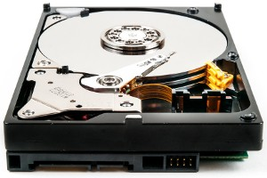

A computer requires an operating system to allow users to interact with and use it. The **operating system** interprets keyboard and mouse movements and allows for the use of software, like an Internet browser, word processor, and video games.

A hard drive is also required for the installation of any **programs** or other files you want to keep on your computer. When downloading files to your computer, they are permanently stored on your hard drive or another storage medium until they are moved or uninstalled.

Modern computers often use an **SSD** (solid-state drive) as the primary storage device, instead of an **HDD**. HDDs are slower than SSDs when reading and writing data, but offer greater storage capacity for the price.

1. **RAM (Random Access Memory)**

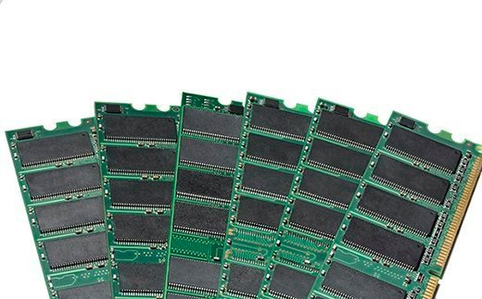

RAM (Random Access Memory) is the hardware in a computing device where the **operating system (OS)**, application programs and data in current use are kept so they can be quickly reached by the device's **processor**. RAM is the main memory in a computer.

Random Access Memory is volatile. That means data is retained in RAM as long as the computer is on, but it is lost when the computer is turned off. When the computer is rebooted, the OS and other files are reloaded into RAM, usually from an HDD or SSD.

computer also works this way. If RAM fills up, the computer's processor must repeatedly go to the hard disk to overlay the old data in RAM with new data. **This process slows the computer's operation.**

1. **ROM (Read Only Memory)**

ROM means Read-Only Memory. It refers to computer memory chips containing permanent/semi-permanent data. Unlike RAM, ROM is **non-volatile**; even after you turn off your computer, the contents of ROM will remain.

Almost every computer comes with a small amount of ROM containing the **boot firmware**. This consists of a few kilobytes of code that tell the computer what to do when it starts up, e.g., running hardware and loading the operating system into RAM. On a PC, the boot firmware is called the **BIOS**.

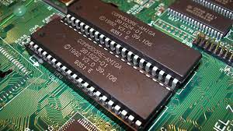

* **Discuss all digital devices that you own, such as laptop, mobile, smart watch, etc. And explain their unique functionalitties**

**LAPTOP**

I have a Dell Latitude 7490

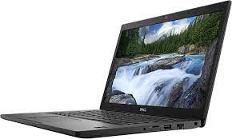

With it’s amazing battery I can use my laptop all day anywhere I want without sitting on a desk. I can do programming, earn online, watch netflix and basically anything that this day and age has to offer. I am currently having an online class due to COVID-19. But with the help of my laptop I can attend my classes at home.

**SMARTPHONE**

I have a Huawei Y9 Prime 2019

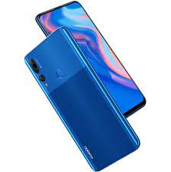

This is my daily driver and always stays in my pocket all the time. I can contact anyone anywhere. I use social media and consume all the online content on this device. It has an amazing camera which help me capture wonderful photos. I can record videos of my cherished moments. I can receive a notification of the emails as soon as possible they are sent, which helps me to be upto date